# Granny Smith Productions

**Design Document for:**

# Escape from Katan

**The Hectic Arcade Shooter Experience**

All work Copyright ©1999 by Granny Smith Productions

Written by Alistair Ball

Version # 1.00

**Game Overview: Philosophy**

Escape from Katan is a game that aims to create an atmosphere of a hectic arcade shooter. I didn’t want there to be any complicated controls or objectives. Escape from Katan may seem uninspired but I’m not trying change the industry, just pay homage to the classics.

**Game Overview: Common Questions**

### What is the game?

The game is a large scale escape mission out of a military controlled city of Katan. There is more than one way to escape but that is up to the player to discover.

I also gave the player a substantial amount of health so they can appreciate the action as opposed to be hiding behind cover trying to survive.

### Why create this game?

The purpose of Escape from Katan is to be an approachable game to all demographics of gamers. It is both fun and easy to play.

### Where does the game take place?

It takes place I the main city of Katan. Katan is a fictional location based on the middle east. You begin in the public prison cell and will have to escape the city once freed.

### What do I control?

You take control of a human male/female prisoner that can run and gun around the surroundings until death or escape. You can run, jump, and shoot.

### How many characters do I control?

You can only control the provided main character.

### What is the main focus?

The focus is to escape the city in any way you can. There are several ways to escape, although each escape route has some pre requisite items that the character must obtain during the game.

### What’s different?

The difference with this game is that there are not a lot of developers making simple games like this. Escape from Katan is designed to be nostalgic for those who know how an arcade shooter plays.

**UI**

**Health Bar:**

The player will have a health bar in the top right of the screen that depletes based on damage taken. The player cannot regenerate health over time, they must find health pickups.

**Stamina Bar:**

When the player sprints, a bar under the health bar in the top right will deplete and when empty the player will not be able to sprint until the bar regenerates. The stamina bar will regenerate quickly once the player stops sprinting.

**Ammo:**

At the bottom right there will be an ammo value for the equipped weapon. It will show how much ammo you have in total as well as how much ammo remains in the clip. The player can hold as much ammo as they can find during the game.

**Feature Set**

## General Features

Large world map.

3D graphics.

Tons of enemies.

Multiple endings.

## Multiplayer Features

Split screen.

Easy to jump in with a friend.

## Editor

No Editor system.

## 

## Gameplay

Variety of weapons.

Variety of enemies.

Variety of Pickups.

Good Soundtrack.

**Game World: Features**

The game world will feature:

Gates that can be unlocked using keys.

Stairs to get to higher vantage points.

Confined spaces and open areas for combat variety.

**Game World: The Physical World**

**Points**

### Key Locations

Centre of town- has a locked weapon, that if unlocked, can greatly assist the player.

Marine docks- A possible escape route

Prison area- Starting area, also has good weapons if player searches

Main Gates- A possible escape route

Tunnel- Tunnel that the player can dig into (if they have acquired the shovel) and escape.

### Travel

The player moves by walking at normal pace, running at faster pace, or crouching at slower pace than walking.

### Scale

The Scale of the world applies to the real world. Your are a regular sized human in a large city.

### Objects

Game objects include:

-Houses of varying sizes

-Gates

-Trees (dead and alive)

-Guns

-Tents

-

### Day and Night

Day mode is the regular play mode where the area is well lit and the enemies are balanced to gameplay.

Night mode is like “hard” mode, the enemies are tougher and it is harder to see your surroundings to escape.

### Time

Time relative to the game will not affect gameplay.

**Game World: The World Layout**

The game layout is both large and confusing. There is little to nothing telling you where to go, and all the buildings and obstacles look very similar. You will consistently start in the same area which will have the same layout.

The theme of the game world is that of a middle eastern city.

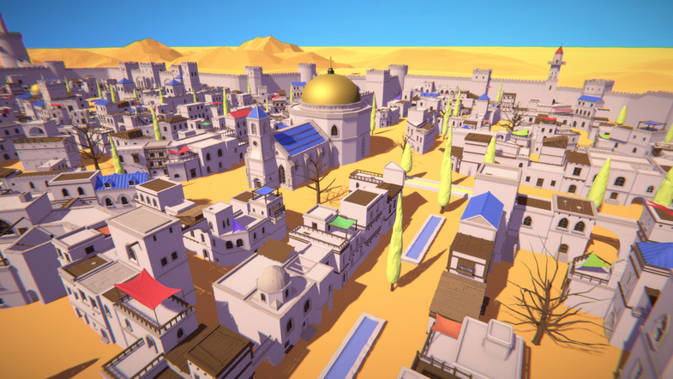

**Obstacle Type 1: Description**

Locked doors/gates: There will be locked gates and doors that can be unlocked with keys. You can unlock doors and gates with any of the keys you find. Keys are limited and some gates wont lead anywhere useful.

**Obstacle Type 2: Description**

Low passageways: These may not seem like important obstacles but Escape from Katan is centered around being hectic and having lots of enemies. This means that maneuverability and speed is crucial which are both impaired while crouching, which is necessary to pass these low areas.

**Enemy Type 1: Description**

Guard: These are the run of the mill enemies. Average health, low damage weapons and very numerous.

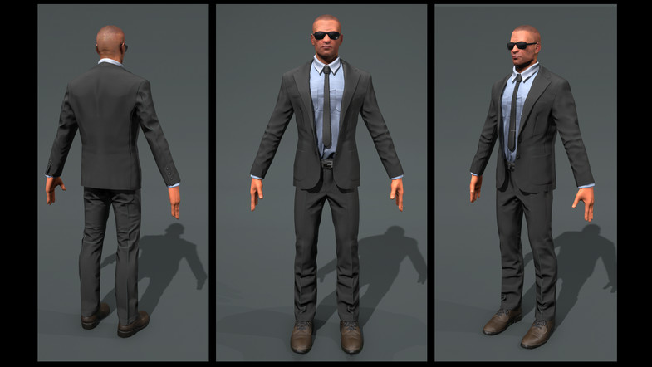

**Enemy Type 2: Description**

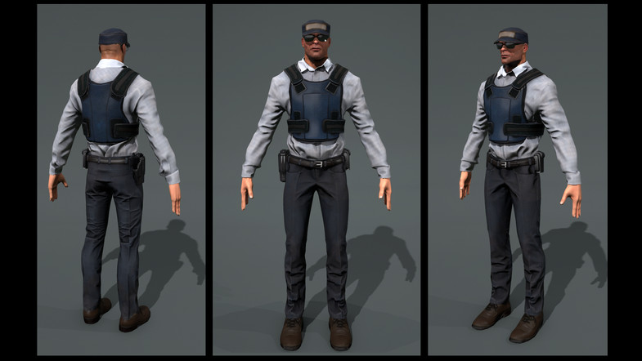Elite Guards: These guards are identified with Kevlar vests. High health, high damage weapons, but fewer around the map. These enemies can drop health for your character once killed.

**Enemy Type 3: Description**

Attack helicopters: These are the hardest enemies as they are hard to hit, very mobile, have the most damaging weapons and lots of health. If you do take on of these down, you will be rewarded with lots of useful items like health and ammo/guns.

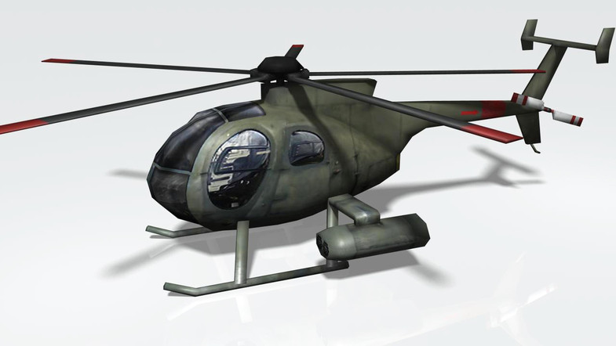

**Game Characters: Character Overview**

Game is in first person, so the character is never seen. The equipped weapon will be jutting out in view of the player but no character detail will be present.

**Weapons: Description**

Pistol: starting weapon, low damage, accurate, lots of ammo.

AK-47: rapid firing, not very accurate long range, good damage output, ammo harder to come by.

Shotgun: slow fire rate, high damage up close, ammo very difficult to come by.

Rocket launcher: special weapon, highest damage output, accurate for most ranges, limited ammo.

**Collectible Type 1: Description**

Keys: Can be found around the world, they allow the opening of any locked gate. These keys can be dropped by enemies as well as found in various locations around the map.

**Collectible Type 2: Description**

Miscellaneous items: items necessary for the various escape options, these include shovel, rope, tarp, or master key.

**Power-up Type 1: Description**

Health: will raise the characters health by 50 (total health 200). Can be dropped by some enemies.

**Power-up Type 2: Description**

Variety of weapons: I consider a power up to the starting pistol. Once you pick up a weapon it comes with some ammo. If you pick up the same weapon as the one you have equipped it will add ammo to the weapon. You can carry as many weapons as you want and switch between them freely.

**Single Player Game**

The single player has the player make his way through the map and escape.

**Hours of Gameplay**

The gameplay would range anywhere from 10 minutes to 30 depending on if the player knows where to go or what to do.

**Multi-Player Game**

Both players work together to escape Katan. More enemies will spawn and both players will share keys. Players will not share weapon drops or ammo, so minimal level of cooperation is necessary.